**Supplementary Material**

**Socioeconomic and human behavioral factors associated with *Aedes aegypti* (Diptera: Culicidae) immature habitat in Tucson, Arizona.**

**K. R. Walker, D. Williamson, Y. Carrière, P. A. Reyes-Castro, S. Haenchen, M. H. Hayden, E. Jeffrey Gutierrez, K. C. Ernst**

**Supplementary Tables S1: Mean (log(total containers +1)) by significant categorical explanatory variables.**

Table S1a: Total containers by home ownership.

|  |  |  |
| --- | --- | --- |
| Question: Do you own this home or do you rent? | N | Mean(log (total containers + 1)) |
| Owner | 264 | 0.89 ± 0.03 |
| Renter | 90 | 0.78 ± 0.05 * |

* Number of containers was significantly lower for renters than owners, *p* = 0.0007

Table S1b: Total containers by income.

|  |  |  |
| --- | --- | --- |
| Question: What was your total household income from all sources last year? | N | Mean(Log (total container) + 1) |
| < $35,000 (reference level) | 105 | 0.97 ± 0.05 |
| $35,000 - $49,999 | 86 | 0.78 ± 0.05 * |
| $50,000 - $74,999 | 66 | 0.94 ± 0.05 * |
| $75,000 - $99,999 | 34 | 0.82 ± 0.06 * |
| $100,000 or more | 63 | 0.76 ± 0.05 ** |

* Number of containers was significantly lower compared to reference level, *p* ≤ 0.038

** Number of containers was marginally lower compared to reference level, *p* = 0.061

Table S1c: Total containers by use of yard service:

|  |  |  |
| --- | --- | --- |
| Question: Do you have a yard service that maintains your yard? | N | Mean(log (total containers + 1)) |
| No | 283 | 0.90 ± 0.03 |
| Yes | 71 | 0.73 ± 0.05 * |

* Number of containers was significantly lower for houses with yard service, *p* = 0.006

Table S1d: Total containers by reported frequency of checking for standing water.

|  |  |  |
| --- | --- | --- |
| Question: Since May, how often have you checked around your house and removed standing water? | N | Mean(log (total containers + 1)) |
| Never checked (reference level) | 95 | 0.83 ± 0.05 |
| After every rainfall | 64 | 0.90 ± 0.06 * |
| Once or twice a month | 39 | 0.92 ± 0.08 |
| Once a week | 49 | 0.93 ± 0.06 |
| More than once a week | 44 | 0.91 ± 0.06 |
| Daily | 38 | * 1. ± 0.08 * |

* Number of containers was significantly higher compared to reference level, *p* ≤ 0.046

**Supplementary Tables S2: Percentage of houses with containers with *Ae. aegypti* larvae by significant categorical explanatory variables.**

Table S2a: Percentage of houses with *Ae. aegypti* larvae by income.

|  |  |  |  |
| --- | --- | --- | --- |
| Question: What was your total household income from all sources last year? | N | Total houses with larvae | Percentage of houses with larvae |
| < $35,000 (reference level) | 105 | 20 | 19.0 |
| $35,000 - $49,999 | 86 | 12 | 14.0 |
| $50,000 - $74,999 | 66 | 4 | 6.1 * |
| $75,000 - $99,999 | 34 | 3 | 8.8 |
| $100,000 or more | 63 | 8 | 12.7 |

* Odds of containers with larvae were significantly lower compared to reference level, *p* = 0.0051

Table S2b: Percentage of houses with *Ae. aegypti* larvae by reported frequency of checking for standing water.

|  |  |  |  |
| --- | --- | --- | --- |
| Question: Since May, how often have you checked around your house and removed standing water? | N | Total houses with larvae | Percentage of houses with larvae |
| Never checked (reference level) | 95 | 14 | 14.7 |
| After every rainfall | 64 | 8 | 12.5 |
| Once or twice a month | 39 | 7 | 17.9 |
| Once a week | 49 | 6 | 12.2 |
| More than once a week | 44 | 3 | 6.8 * |
| Daily | 38 | 5 | 13.2 |

* Odds of containers with larvae were significantly lower compared to reference level, *p* = 0.036

**Supplementary Tables S3: Percentage of houses with containers with *Ae. aegypti* pupae by significant categorical explanatory variables.**

Table S3a: Percentage of house with *Ae. aegypti* pupae by home ownership.

|  |  |  |  |
| --- | --- | --- | --- |
| Question: Do you own this home or do you rent? | N | Total houses with pupae | Percentage of houses with pupae |
| Owner | 264 | 15 | 5.7 |
| Renter | 90 | 5 | 5.5 * |

* Odds of containers with pupae were significantly lower for renters than owners, *p* = 0.0006

Table S3b: Percentage of houses with *Ae. aegypti* pupae by income.

|  |  |  |  |
| --- | --- | --- | --- |
| Question: What was your total household income from all sources last year? | N | Total houses with pupae | Percentage of houses with pupae |
| < $35,000 (reference level) | 105 | 10 | 9.5 |
| $35,000 - $49,999 | 86 | 6 | 7.0 * |
| $50,000 - $74,999 | 66 | 3 | 4.5 * |
| $75,000 - $99,999 | 34 | 0 | 0 * |
| $100,000 or more | 63 | 1 | 1.6 |

* Odds of containers with pupae were significantly lower compared to reference level, *p* ≤ 0.012

Table S3c: Percentage of houses with *Ae. aegypti* pupae by reported frequency of checking for standing water.

|  |  |  |  |
| --- | --- | --- | --- |
| Question: Since May, how often have you checked around your house and removed standing water? | N | Total houses with pupae | Percentage of houses with pupae |
| Never checked (reference level) | 95 | 5 | 5.3 |
| After every rainfall | 64 | 4 | 6.3 |
| Once or twice a month | 39 | 3 | 7.7 |
| Once a week | 49 | 2 | 4.1 |
| More than once a week | 44 | 0 | 0 * |
| Daily | 38 | 5 | 13.2 |

* Odds of containers with pupae were significantly lower compared to reference level, *p* = 0.020

**Supplementary Table S4: Mean (log(container +1)) of different container types by income**

|  |  |  |  |  |  |
| --- | --- | --- | --- | --- | --- |
|  | Household Income | | | | |
| Container Type | < $35,000  (N=105) | $35,000 to $49,000  (N=86) | $50,000 to $74,999  (N=66) | $75,000 to $99,999  (N=34) | $100,000 or more  (N=63) |
| Trash | 0.219 ± 0.039 | 0.104 ± 0.024* | 0.168 ± 0.040 | 0.074 ± 0.033* | 0.072 ± 0.021* |
| Tires | 0.053 ± 0.015 | 0.028 ± 0.014 | 0.080 ± 0.028 | 0.009 ± 0.009 | 0.014 ± 0.011 |
| Plastic containers | 0.469 ± 0.036 | 0.403 ± 0.039 | 0.485 ± 0.048 | 0.421 ± 0.061 | 0.289 ± 0.047 |
| Flower pots | 0.533 ± 0.049 | 0.421 ± 0.049* | 0.505 ± 0.056 | 0.471 ± 0.073 | 0.395 ± 0.049* |
| Toys | 0.165 ± 0.027 | 0.097 ± 0.024 | 0.133 ± 0.031 | 0.070 ± 0.029* | 0.057 ± 0.020* |
| Cement troughs | 0.043 ± 0.012 | 0.038 ± 0.013 | 0.035 ± 0.015 | 0.049 ± 0.021 | 0.017 ± 0.010 |
| Tarps | 0.020 ± 0.008 | 0.025 ± 0.009 | 0.028 ± 0.013 | 0.067 ± 0.028* | 0.029 ± 0.013 |
| Other small cont. | 0.179 ± 0.027 | 0.171 ± 0.026 | 0.172 ± 0.029 | 0.132 ± 0.37 | 0.186 ± 0.034 |
| Large containers | 0.064 ± 0.014 | 0.043 ± 0.015 | 0.090 ± 0.022 | 0.018 ± 0.012 | 0.141 ± 0.025* |

* Denotes a value significantly difference from that of the lowest income category (*p* < 0.05).

Supplementary Figure 1: Association between household income and total containers.

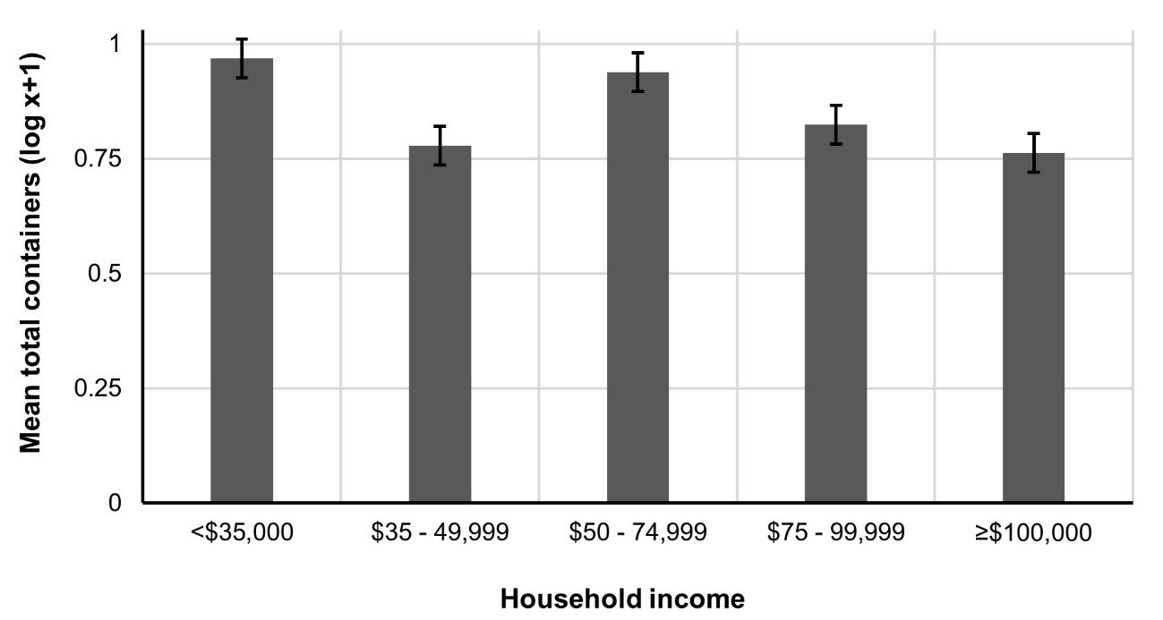

Total container number was log transformed (log(X + 1)) to improve assumptions of normality.